Camden-Frontier Board of Education
Special Meeting – 6:00 pm - May 9, 2022 - Cafeteria/MPR
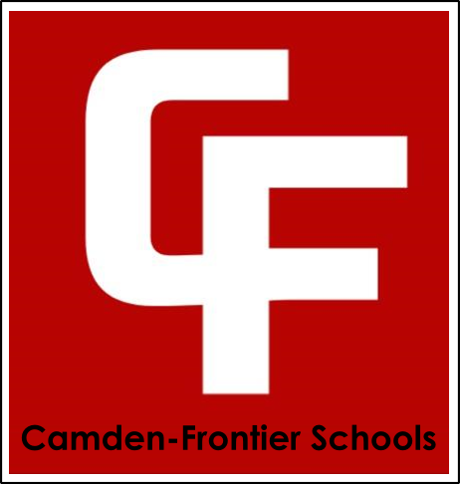

- Call to Order & Roll Call
Our Mission
The Camden-Frontier School community including staff, students, parents and stakeholders will provide a foundation of educational opportunities that enable all students to succeed in our changing society.
- Pledge of Allegiance
- Changes or Additions to the Agenda
- Approval of Previous Meeting Minutes
- Public Comment
- Adjournment

